- Networks Threats and Migration

Q1. Create a table listing 5 common network threats (such as phishing, DDoS, man-in-the-middle, malware, and password attacks), and for each, write one real-world example from an app or service you use (like WhatsApp, Instagram, or Paytm)?
Answer
Network threats are activities that can damage a network, steal information, or gain unauthorized access. Five common network threats are
Network Threat | Simple Meaning | Real-World Example
1. Phishing | Fake messages or websites are used to steal personal information. | A fake Paytm message asks a user to click a link and enter their login details.
2. DDoS Attack | A server receives a huge amount of traffic, making the service unavailable. | An Instagram server receives大量 automated requests, causing the service to become slow or unavailable.
3. Man-in-the-Middle (MITM) | An attacker secretly intercepts communication between two devices. | On unsafe public Wi-Fi, an attacker may try to intercept traffic between a phone and an online service.
4. Malware | Harmful software is used to damage a device or steal information. | A user downloads a fake WhatsApp application containing malware that steals information.
5. Password Attack | Attackers try to guess or steal a user's password. | An attacker repeatedly tries different passwords to gain access to an Instagram account.

- Conclusion:
Network threats can affect both users and online services. Using strong passwords, two-factor authentication, secure connections, and trusted applications can help reduce these risks.

Q2. Simulate a brute-force attack scenario by writing a simple Python script that tries to guess a 4-digit PIN code by checking all possible combinations against a preset value.<br><br><em><strong>Constraint:</strong> The script should print the number of attempts it took to guess the correct PIN.</em>?

Answer
In this simulation, the correct PIN is already stored in the program. The program starts from 0000 and checks each possible PIN until the correct one is found.

- Python Code:

correct_pin = "2580"
attempts = 0

for i in range(10000):
guess = str(i).zfill(4)
attempts += 1

if guess == correct_pin:
print("Correct PIN found:", guess)
print("Number of attempts:", attempts)
break

- Output:
- Correct PIN found: 2580
- Number of attempts: 2581

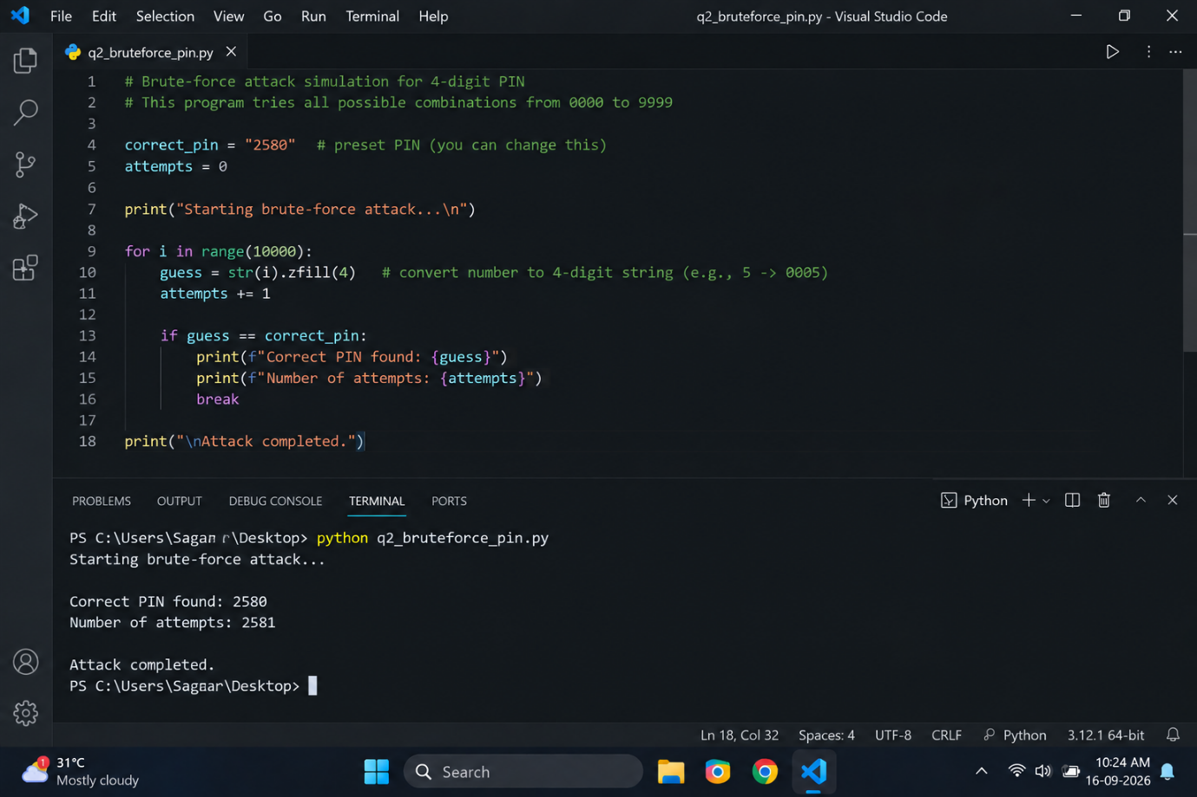

- Explanation:
The program checks PINs from 0000 onward. It finds the correct PIN 2580 after 2581 attempts.
- Result:
The program successfully simulates a brute-force PIN guessing process and displays the total number of attempts.

Q3. List 4 physical security risks that could affect a server room hosting a popular app like Zomato or BookMyShow, and suggest one mitigation step for each risk?

Answer
A server room contains important network equipment and data. Physical security is necessary to protect it from damage and unauthorized access.
Physical Security Risk | Mitigation / Prevention
1. Unauthorized Access | Use biometric or access-card locks so only authorized staff can enter.
2. Fire | Install smoke detectors and suitable fire suppression systems in the server room.
3. Water Damage | Keep servers away from water pipes and install water-leak detection systems.
4. Power Failure | Use a UPS (Uninterruptible Power Supply) and backup power system.

- Conclusion:
These security measures can help protect servers used by services such as Zomato or BookMyShow from physical damage, unauthorized access, and service interruptions.

Q4. Draw a simple floor plan (hand-drawn or digital) of a small office and mark at least 3 physical security measures you would implement to protect network equipment (such as CCTV, biometric access, or cable locks)?

Answer
The above floor plan shows a small office with physical security measures used to protect network equipment.
- The following three security measures are implemented:
- CCTV Cameras: Installed near the main entrance and office area to monitor activities and detect unauthorized persons.
- Biometric Access: Installed at the server room so that only authorized staff can enter.
- Cable Lock: Used to physically secure network equipment and help prevent theft.
- Result:
The office floor plan uses CCTV, biometric access, and cable locks to improve the physical security of network devices and important data.
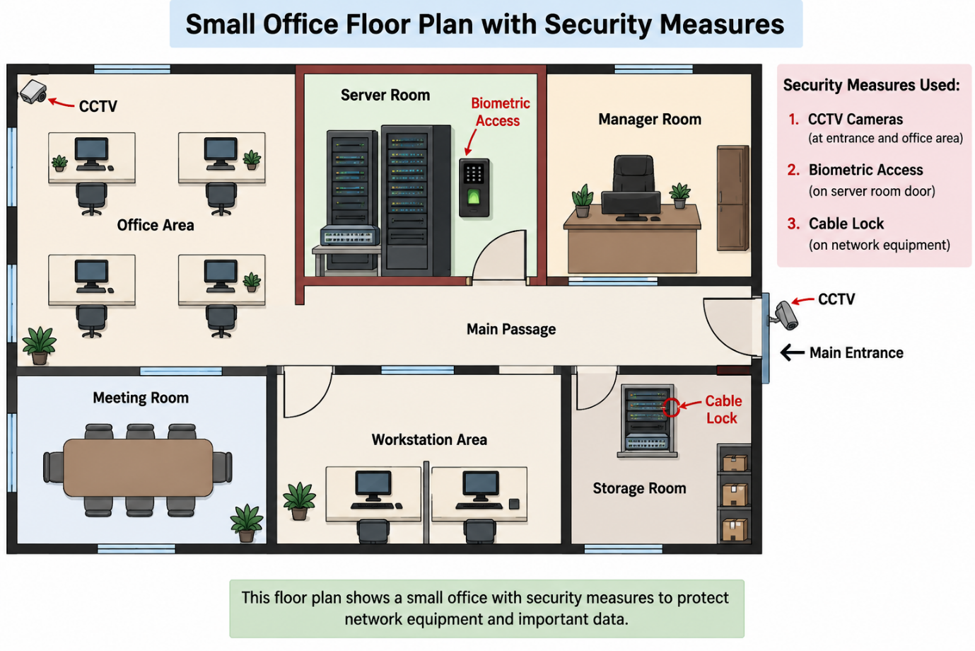

Q5. Use ChatGPT or a similar AI tool to generate a checklist of 7 actions a network admin should take to mitigate risks from both network threats and physical security breaches, then review and edit the checklist to make it specific for a college computer lab environment?

Answer
The following checklist contains 7 actions a network administrator should take to protect a college computer lab from network threats and physical security breaches.

Security Action | Purpose
1. Install and update antivirus software | Protect lab computers from malware and viruses.
2. Use strong passwords | Prevent unauthorized access to computers and network devices.
3. Configure firewall rules | Block unwanted and suspicious network traffic.
 | Install security updates on Windows, browsers, and other lab software.
  4. Keep software updated
 | Monitor the computer lab and help prevent theft or misuse.
  5. Install CCTV cameras
6. Restrict access to network equipment | Keep routers, switches, and servers in a locked room or cabinet.
  7. Take regular backups
  Protect important college files and data in case of system failure or attack.

- Review and Edit:
This checklist is specifically designed for a college computer lab, where many students use shared computers and network resources.
- Conclusion:
Following these steps can help the network administrator protect the college computer lab from both network attacks and physical security risks.

